Documentation Template

| ***You MUST provide evidence showing how the problem has been decomposed, how the components have been developed and trialled, and of how they have been assembled and tested to create a final, working outcome.*** |
| --- |

### Outline / Decomposition

* *Welcome*
* *Instructions*
* *Enter to generate random number*
* *Ask guesser for input*
* *Right or not*
* *Tell the user how many turns they have left*
* *Only 10 go’s*
* *Can’t enter the same number more than once*

### Version Log

*Your version log should go here. Annotated screenshots are a good idea at this point*

*10 March*

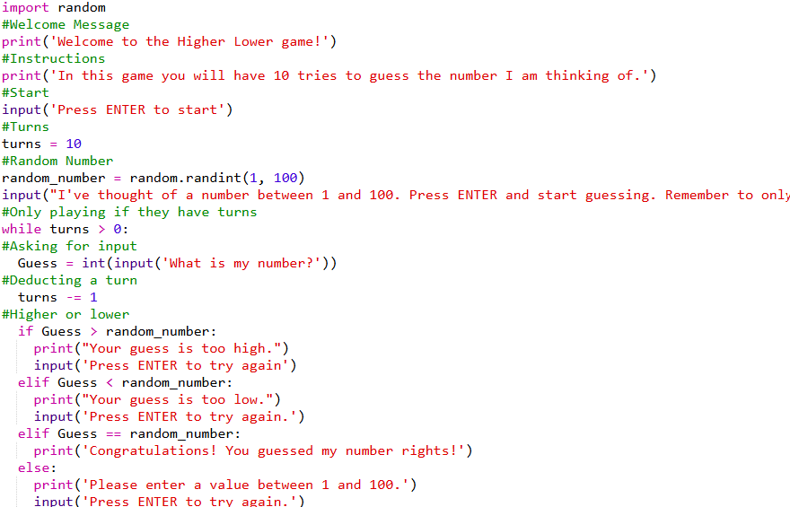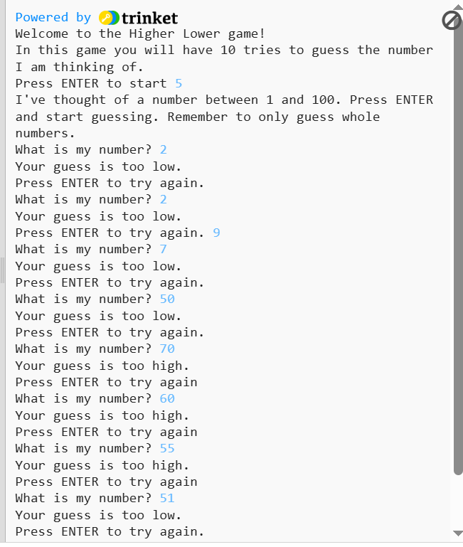

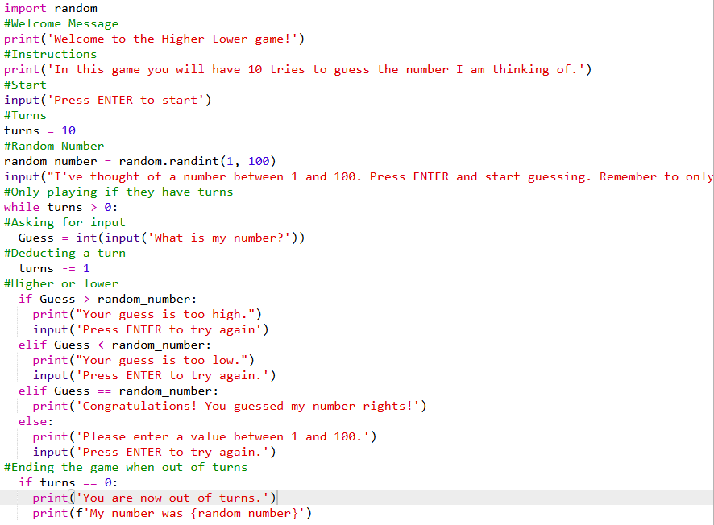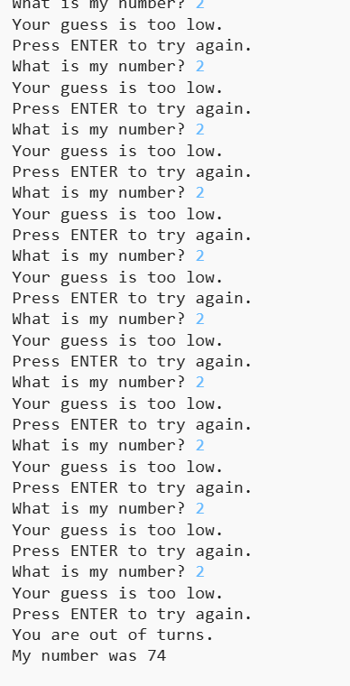

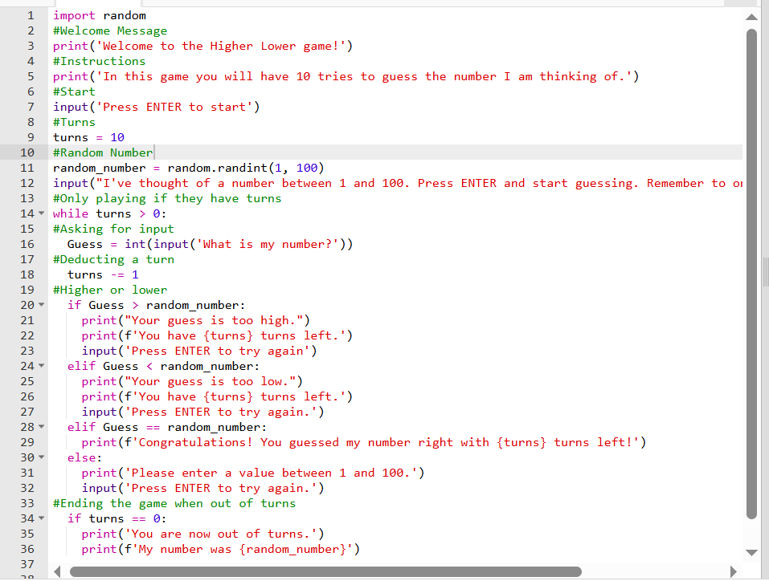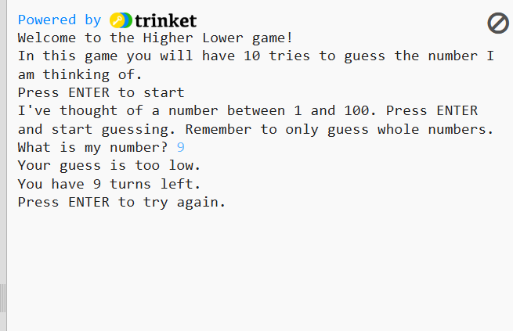

### Component Testing

*Show that you have tested each component here. You should have a test plan and then screenshot proof for each component. You should also include notes that justify the major decisions you made.*

### Assembled Outcome Testing

*Please show testing for your assembled outcome below. This should include a test plan followed by screenshot proof*

### Usability Testing

*Write a list of things improvements which need to be made based on your usability testing. Then write down what you changed.*

### Post Usability Test…

*Show that your post usability testing program works correctly*

### Social and End User Considerations…

**How did you ensure that your task was suitable for your chosen audience?**

*Answer here*

**How have you honoured copyright?**

*Answer here*

**How did you make your quiz easy to use?**

*Answer here*

*import random*

*#Welcome Message*

*print('Welcome to the Higher Lower game!')*

*#Instructions*

*print('In this game you will have 10 tries to guess the number I am thinking of.')*

*#Start*

*input('Press ENTER to start')*

*#Turns*

*turns = 10*

*#Random Number*

*random_number = random.randint(1, 100)*

*input("I've thought of a number between 1 and 100. Press ENTER and start guessing. Remember to only guess whole numbers.")*

*#Only playing if they have turns*

*while turns > 0:*

*#Asking for input*

*Guess = int(input('What is my number?'))*

*#Deducting a turn*

*turns -= 1*

*#Higher or lower*

*if Guess > random_number:*

*print("Your guess is too high.")*

*input('Press ENTER to try again')*

*elif Guess < random_number:*

*print("Your guess is too low.")*

*input('Press ENTER to try again.')*

*elif Guess == random_number:*

*print('Congratulations! You guessed my number rights!')*

*else:*

*print('Please enter a value between 1 and 100.')*

*input('Press ENTER to try again.')*

*#Ending the game when out of turns*

*if turns == 0:*

*print('You are now out of turns.')*

*print(f'My number was {random_number}')*